Revised phase 1

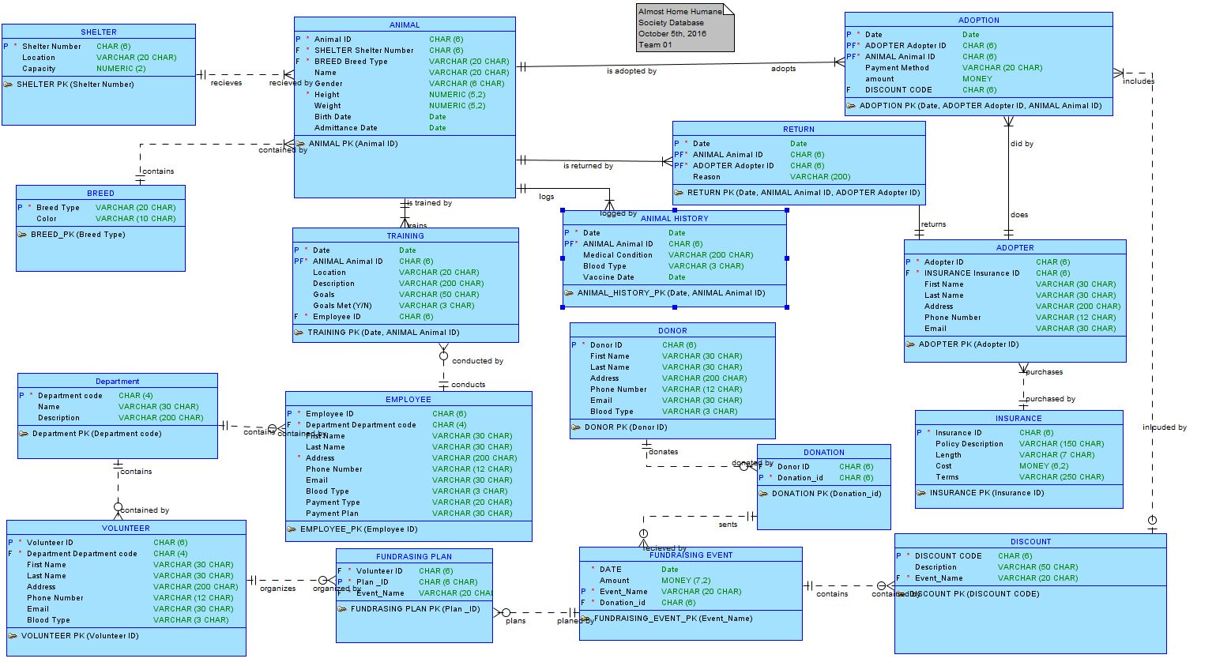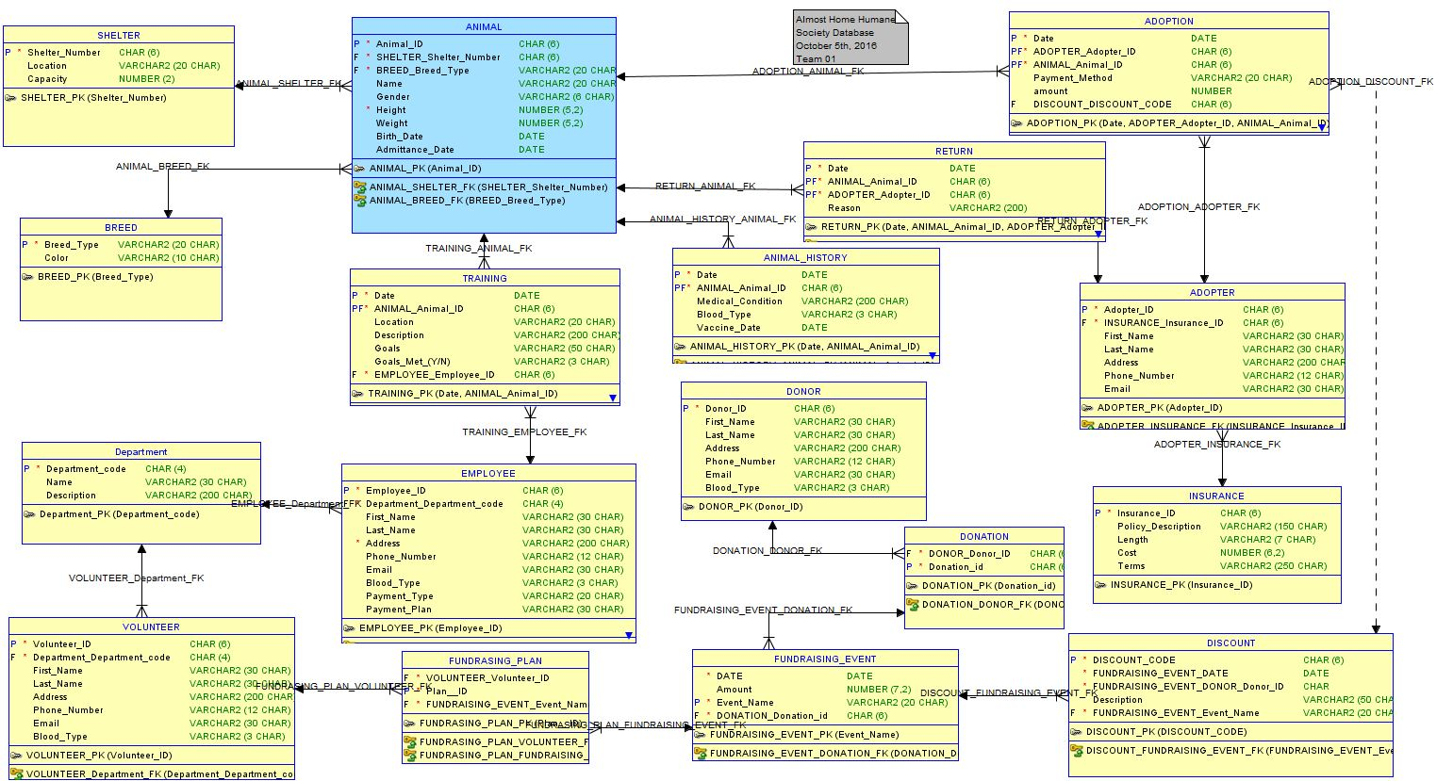

We fixed data type and data size. We also fixed relationship between many to many tables. We added third table between many to many relationships.